Designing Visualization for your manager

The Sales - Superstore dataset contains detailed information about your company’s sales. Your manager, Sylvia, has made a decision to cut the three worst performing sub-categories in their region in terms of Sales. To do this, she has asked you to create one data visualization that will identify which three sub-categories are the worst performers by region, and show how much worse they perform than other sub-categories. Sylvia will use this visualization to inform which product categories to cut, and in which regions.

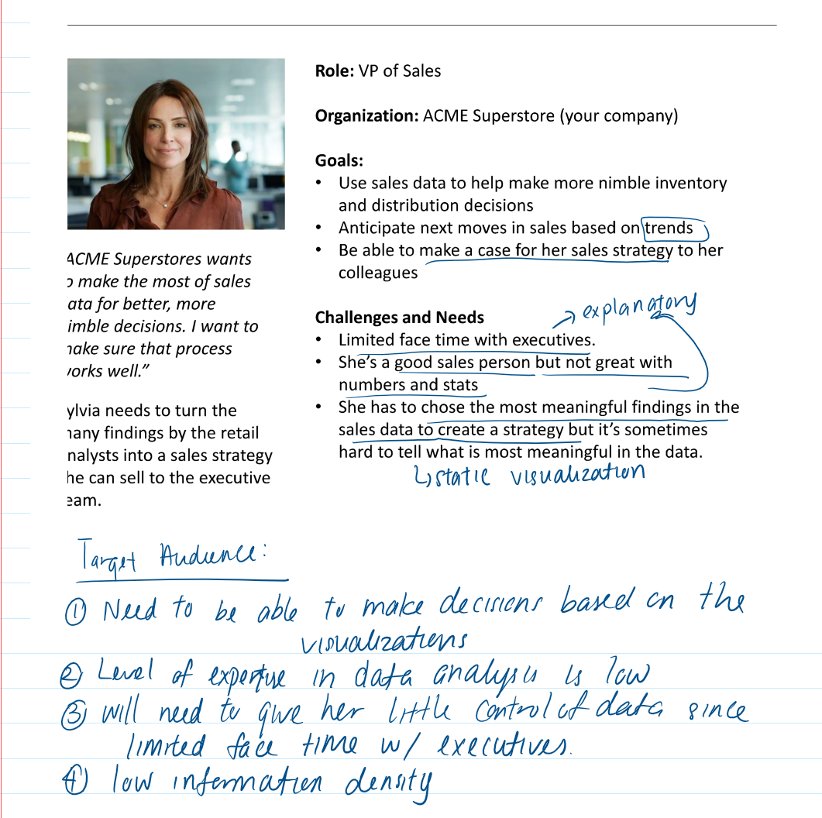

* How does your visualization leverage at least one “pop-out effect” or “pre-attentive attribute?” Which one(s) was (were) chosen and why?

I used colour to bring the user’s attention to the 3 sub-categories with the lowest sales. The bar graphs were ordered in ascending sales order, this uses orientation.

* How does your visualization utilize at least one Gestalt principle? Which principle(s) is (are) being reflected, and how?

The visualization uses Gestalt’s proximity and enclosure principle, which orders the bar graphs in ascending order, and uses colour to highlight the 3 categories with the lowest sales. A reference to the average sales was also uses as enclosure to show how the sales compared to the average sales.

* How does your design reflect an understanding of cognitive load and clutter?

The row labels were removed as they were not needed, and categories which sales were not the bottom 3 were made the same colours. The use of only 2 colours helped reduce clutter.

* Is your visualization static or interactive? Why did you choose that format?

The visualization uses static for all the sales in the country and interactive visualization for showing sales in the region. This format was chosen because the user has low expertise with data analysis and will not need a high level of control. However filtering the sales of the categories by region does not require high expertise, and will help with keeping the page simple.

* What need does this visualization address that words or numbers alone cannot fill?

This visualization showed in a quick glance what the 3 categories with the lowest sales, and also highlights the average category sales for each region, and as a whole.

**Visualizations**

<https://public.tableau.com/profile/rosalind1983#!/vizhome/ACMESuperstore_15789723543890/Salesofeachsub-categorybyregion>

<https://public.tableau.com/profile/rosalind1983#!/vizhome/ACMESuperstore1/totalsalesofeachsub-category?publish=yes>